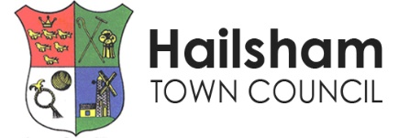
RECEPTIONIST (Maternity Leave)
We’re looking for a dynamic Receptionist to provide efficient and effective support to the corporate management functions of the Council and the Town Clerk.
General Information…
Job Title: Receptionist (Maternity Leave)
Place of Work: Hailsham
Salary: SCP 6 (£25,989 p.a. / £14,048 p.a. pro rata)
Hours: 20 per week (10am-2pm, Monday to Friday)
Contract: Fixed term to cover maternity leave, anticipated duration is approx. 12 months - this may vary depending on the post-holder’s return date.
Closing Date: 4pm on Wednesday 17th December 2025
Interviews: Tuesday 6th January 2026
About Us…
Hailsham Town Council is proud to serve the people of Hailsham, delivering and enabling a range of services to residents and visitors - from parks, allotments and cemeteries to events, community centres, Post Office and Youth Service.
The Role…
In this role, you’ll:
- Greet and assist visitors to the Council offices in a professional and welcoming manner
- Answer and direct telephone calls and emails efficiently
- Manage incoming and outgoing correspondence
- Maintain records and filing systems
- Support administrative tasks as required
If you are friendly, organised and passionate about being the first point of contact for residents and visitors - providing excellent customer service while supporting the smooth running of the council office – then be sure to apply for this job role.
For Key Responsibilities and Criteria please see the Job Description and Person Specification.
Why Join Us?
- Make an Impact: Be part of the continued success of Hailsham Town Council
- Collaborative Environment: Work within a supportive, motivated, and experienced team.
- Training and Development: Access to ongoing professional development and career growth opportunities.
- Work-Life Balance: We offer flexible working hours and a supportive working environment
How to Apply…
Please email enquiries@hailsham-tc.gov.uk for an application pack. If you have any questions about the Town Council or the role, please contact us on 01323 841702 or email emily.hastings@hailsham-tc.gov.uk.
LINK TO VIEW JOB DESCRIPTION AND DOWNLOAD APPLICATION FORM: https://www.hailsham-tc.gov.uk/town-council/staff-member-vacancies/
Applications must be received by 4pm on Wednesday 17th December 2025.

